I will buy you a Hot-Dog

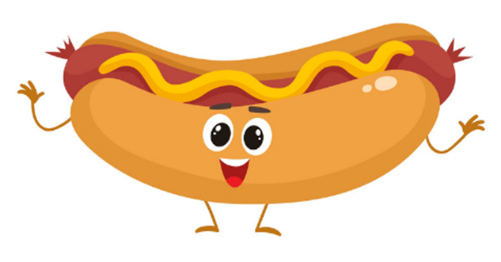

Just help me with some answers for my

app (for gardening)!